**How to screw others in a Social Network: A Dangerous Demonstration**

Disclaimer:  
*This is just for educational purposes. I want to make the reader feel how vulnerable we are while posting in Social Networks. I want to demonstrate with the technology available today, how damn easy it is to screw others.* *Blogger is not responsible for any actions that the reader may be inspired to do after reading this. This supersedes all previous notices.*  
  
  
You will need:

* [Firefox](http://www.mozilla.org/en-US/firefox/new/)/[Chrome](http://www.google.co.in/chrome)
* [Firebug](http://getfirebug.com/downloads)
* Some basic HTML knowledge(which you can gather from [W3Schools](http://w3schools.com/) or [Tizag](http://tizag.com/))
* [Tor Browser](https://www.torproject.org/download/download-easy.html.en) (so that it is not traceable to you)
* Paint/Photoshop/GIMP

N.B. Click on the screenshots to enlarge.  
  
1. Your target must preferably be in your friend list. But that is not necessary. All you need is a publicly shared post. Here, for demonstration purposes, I select a page. You can also do this in other networking sites like Twitter.

 2. Open a post in that page/profile.

[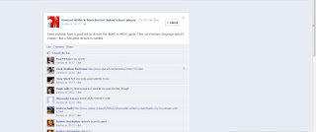](http://2.bp.blogspot.com/-NeLnRdMaD8A/T6oeGiZESxI/AAAAAAAAAdw/PJNLqB4n5yo/s1600/2.jpg)

3. Right click on the body of the post and select '*Inspect Element with Firebug*'.

[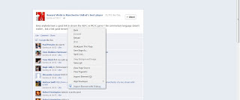](http://2.bp.blogspot.com/-ZtMTf0Mmq_g/T6oeIVJ6DfI/AAAAAAAAAd4/Gvj3FjtfoVQ/s1600/3.jpg)

 4. After Firebug opens, the HTML part of the body of the post would be highlighted. Right click there and select 'Edit HTML'.

[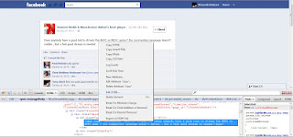](http://4.bp.blogspot.com/-W8U1xqExcrg/T6oeJnBMx4I/AAAAAAAAAeA/PTKAWVKOCpM/s1600/4.jpg)

5. Write whatever you want. Notice the change in the main content.

[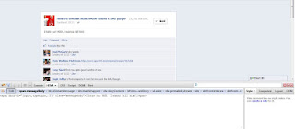](http://1.bp.blogspot.com/-0cJqCk-FVTU/T6oeKc0GgLI/AAAAAAAAAeE/ugg1QEziHHg/s1600/5.jpg)

Point to note here is that you can also use the same technique, and a bit to HTML knowledge, to change the thumbnail picture of the person who has posted this. And of course, changing the name is equally easy.  
  
6. Take a screenshot and save it. Make sure to blur any parts which may reveal your identity like the tabs that are opened or a visible chat list.  
  
7. Close the browser and run Tor. After the successful connection with its servers, it opens a portable firefox window. The purpose is to hide your IP, and Onion Routing is the best way to do it.  
  
8. Open https://mail.google.com and make a new email. Don't be idiotic enough to use your actual name/email/any other detail.  
  
9. Send the screenshot to the required person.  
  
And just in case someone does it to you, show the concerned person this post.